Starters
Smoked Chicken and Bacon Salad
With mixed leaves, croutons & house dressing
Golden Fried Garlic Mushrooms
With house salad & garlic dip
Fried Wedges of Brie Cheese
With mango chutney and rocket leaves
Homemade Soup of the Day
‘Grand Style’ Seafood Chowder

Main Courses
Roasted Stuffed Leg of Killorglin Lamb
With natural gravy
Oven Baked Ballotine of Chicken
Wrapped in bacon, stuffed with Sneem black pudding, with wild mushroom jus
Grilled 8oz Sirloin of Prime Hereford Beef
With Sautee onions and mushrooms
& Choice of pepper sauce or garlic butter
Pan Roasted Fillet of Fresh Atlantic Hake
With a shrimp and caper butter
Golden Fried Goujons of Fresh Cod
In a herb and lemon crumb, with tartare sauce & pea puree
Wild Mushroom, Spinach & Asparagus Risotto
With parmesan shavings and rocket leaves

Desserts
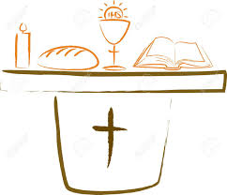
Vanilla and Apple Crème Brulee
Hazelnut & White Chocolate Parfait
With vanilla ice cream
Warm Pear & Almond Tart
Raspberry & Mango Cheesecake
Tea or Coffee

